Autism Friendly
Puke Ariki

Social stories suited
for school visits
(Discover it!)

What is Puke Ariki?

Puke Ariki is a library, museum and an information centre.
The library at Puke Arik includes ‘Discover It!’ (the children’s area), a research centre and the adult library collections.
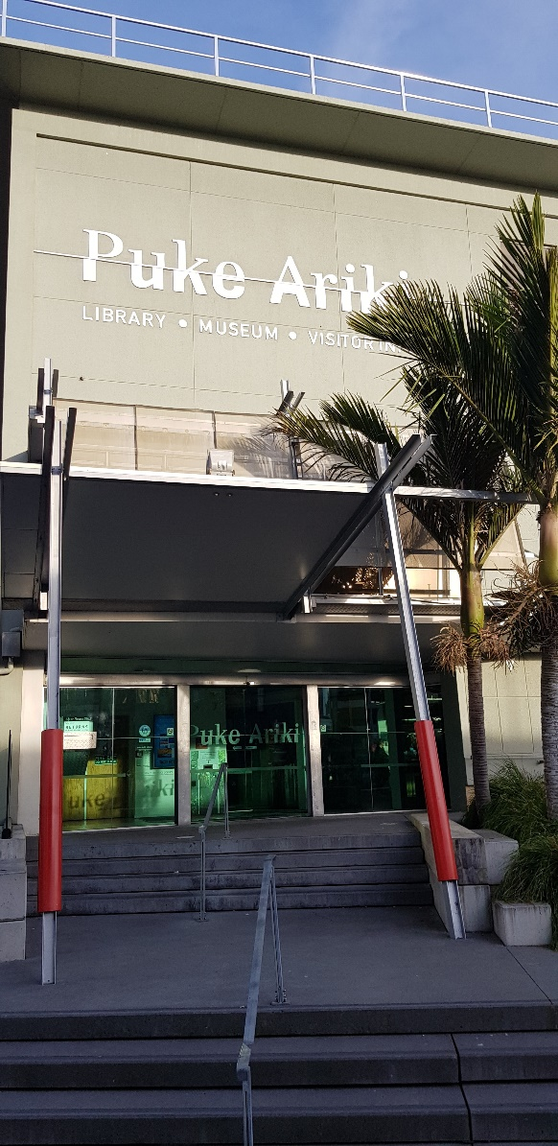
Discover it! contains separate spaces with books for different aged children. We also have magazines, audio books and computers.

How to get to Discover it!

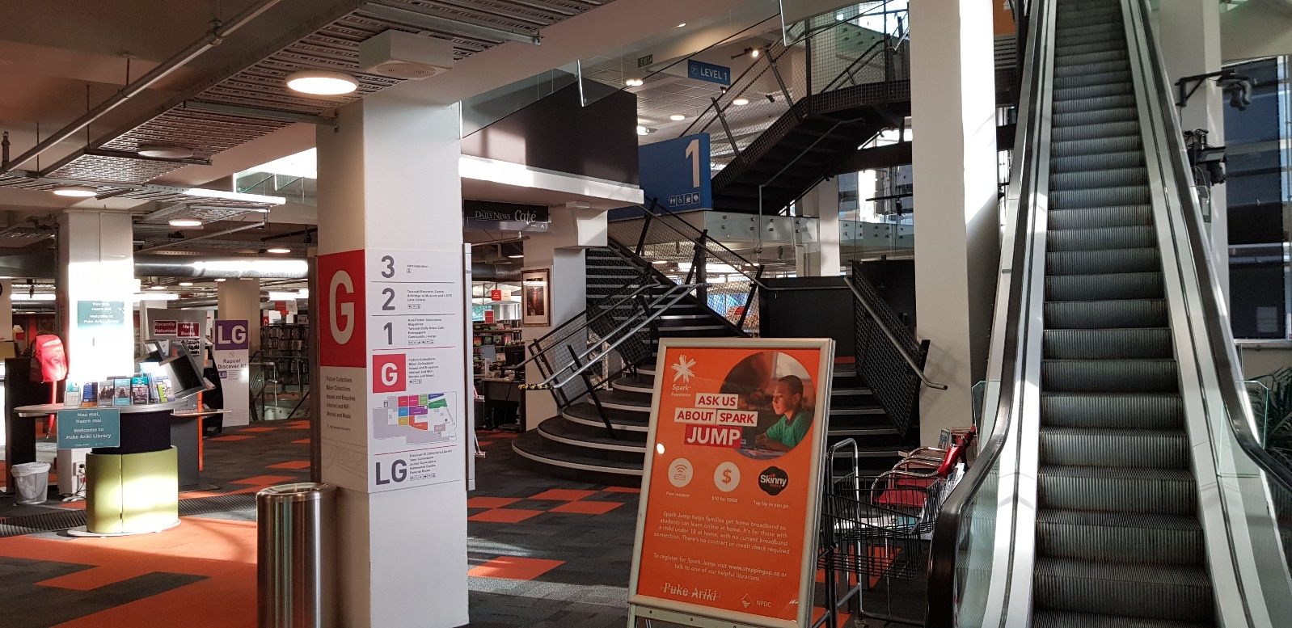

When I walk into the library I will see an escalator and a Help Desk. Sometimes the escalator is running but mostly it is not moving.

Discover it! is in the basement. I can use the stairs, a ramp or a lift to travel down to it.

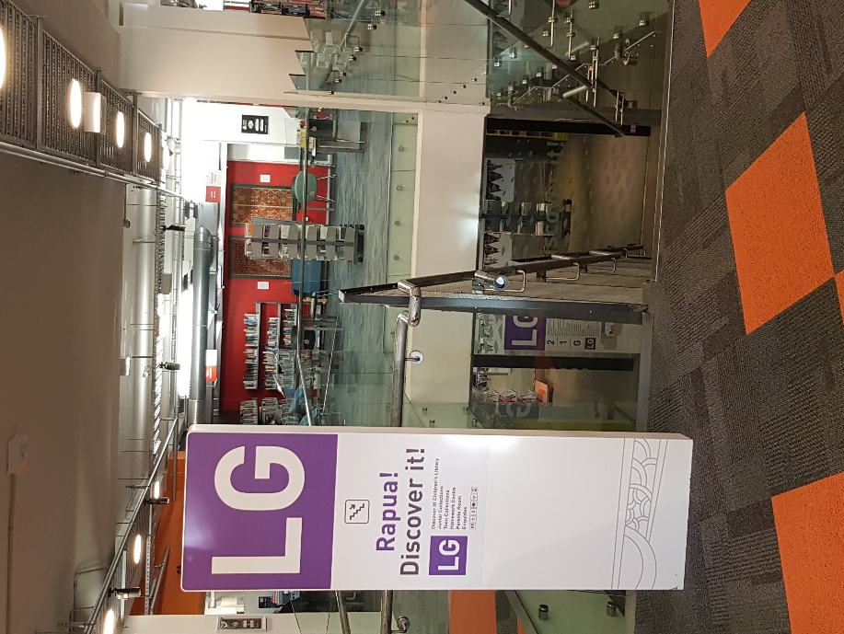

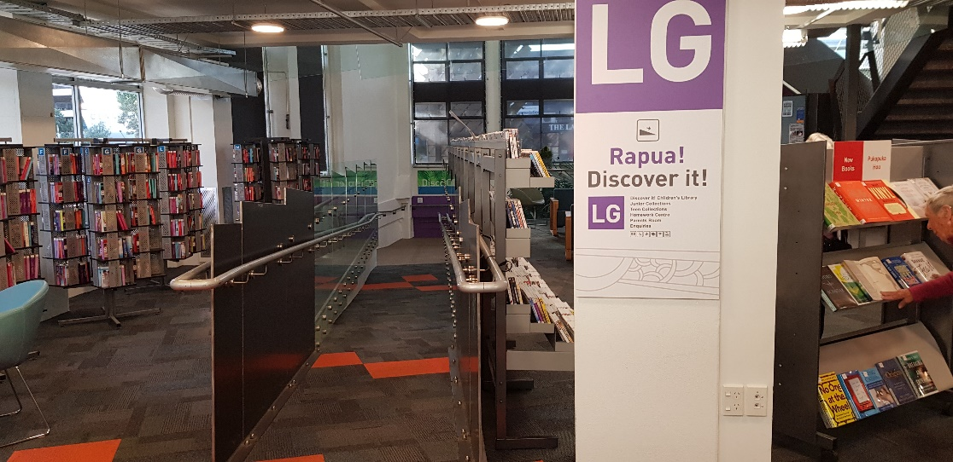

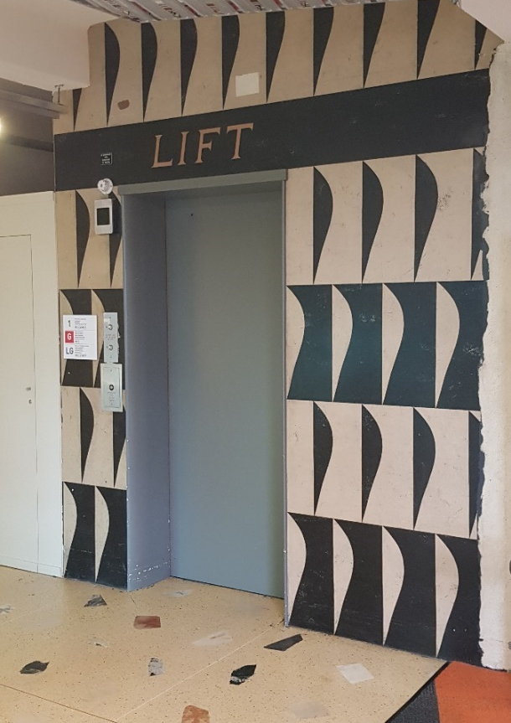

I will listen to my teacher who will tell me and my classmates where to sit and where to leave my bag.

Librarians

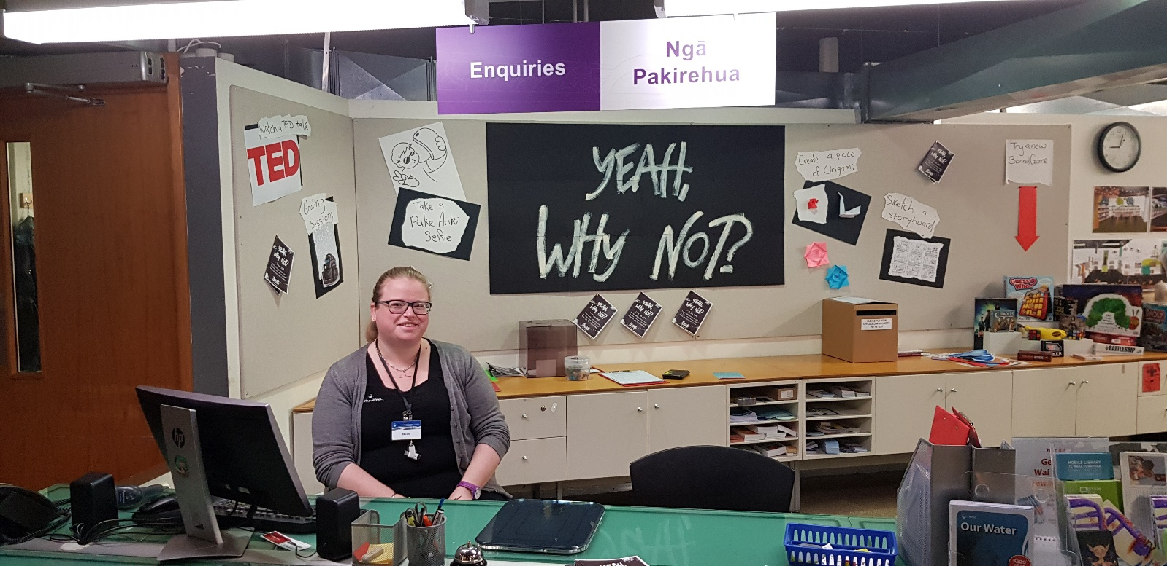

Lots of helpful people work in the Library.
Puke Ariki staff all wear a Puke Ariki badge. If I get lost I can ask a person at the Enquiries Desk to help.

Toilets in Discover it!
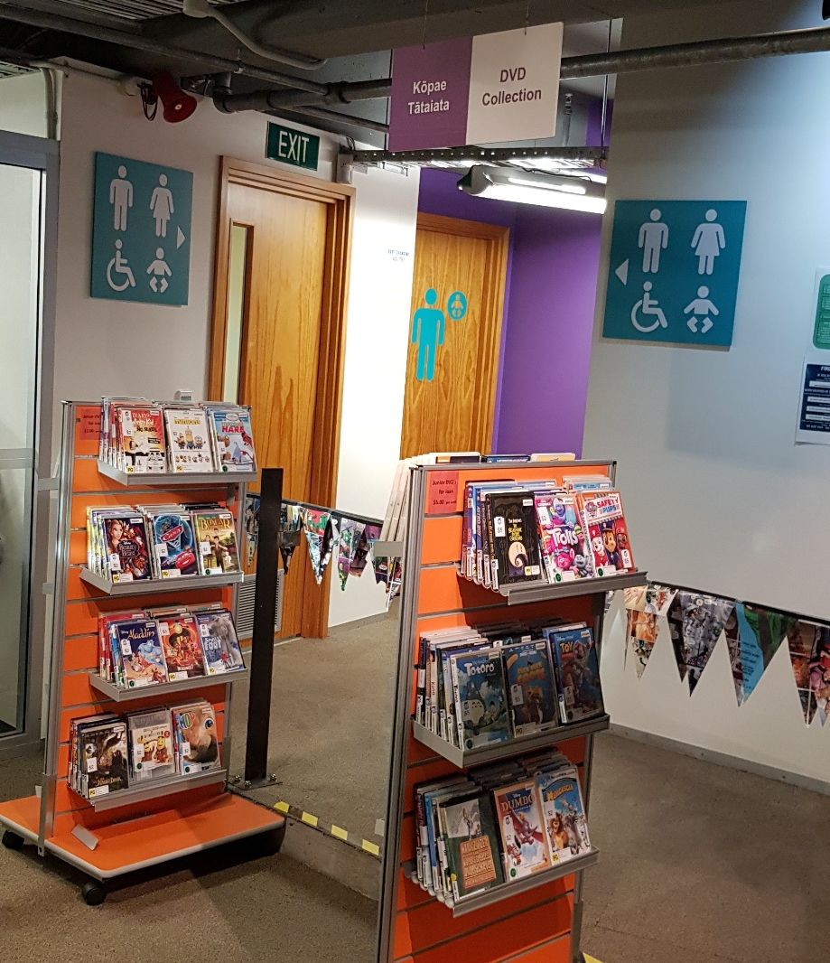
I will tell my teacher or another adult if I need to go to the toilet and they will take me to a bathroom.
There may be other people in the bathroom as well. I will remember to flush the toilet and wash my hands.

Food and water
I can eat food and drink water in Discover it! if my teacher tells me we are having a snack. I will sit down to eat and put my rubbish in the bins.

Discover it! Spaces
Discover it! has different spaces filled with books and other items.
I will listen and wait until the teacher tells me when I can go exploring. I have to stay in Discover it! and not leave the floor.
Some areas might be dark or bright. If I don’t like being in a space and feel uncomfortable I will tell an adult.

Booked sessions
My class might have a special session with a librarian.
My teacher will introduce them to me and my classmates.
The librarian will welcome us to Discover it! and ask questions.
I will listen to the librarian and at the same time try and keep as still as I can.
If I want to answer a question I will put my hand up first. I will not interrupt when the teacher is speaking.

